Multiple choice Qs on Reproduction
- Sex organs develop rapidly during:
- fertilization
- puberty
- menstruation
- ovulation
- The male sex cell is called:
- egg
- ovary
- testis
- sperm
- The release of the egg from an ovary is known as
- fertilization
- ovulation
- negative feedback
- freedom
- Fertilization usually occurs in the .
- ovary
- Fallopian tubes
- vagina
- uterus
- A fallopian tube is a passageway through which an egg travels from the ovary to the uterus.
- True
- False
- What is the hormone responsible for causing sudden emotional changes and sexual feelings that occur in males during puberty?
- estrogen
- testosterone
- LH
- progesterone

- When does conception or fertilization occur?
- a dominant gene overrides a recessive gene.
- sperm from a male unites with an egg from a female.
- an egg matures in a female's ovary.
- all 23 pairs of chromosomes are present.
- The joining of a sperm and an egg is called ovulation.
- True
- False
- Which sequence correctly describes the route sperm take through the human male reproductive system?
- urethra, epididymis, vas deferens
- vas deferens, urethra, epididymis
- epididymis, vas deferens, urethra
- vas deferens, epididymis, urethra
- The ovary contains blood vessels that link the fetus to the mother.
- True
- False
- The new cell that is formed from fertilization is called a .
- ovum
- zygote
- sperm
- gamete
- How are blood and nutrients carried from the mother to the developing fetus?
- placenta
- fallopian tubes
- endometrium
- umbilical cord
- If fertilization occurs, it usually occurs in the uterus.
- True b. False
- What are the ovaries?
- Glands that produce sperm
- the Birth Canal
- Opening to the vagina
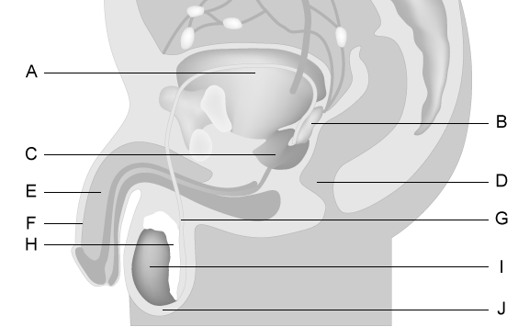
- organs that produce the female's eggs and sex hormones
- The diagram shows the male reproductive system. Which letter represents where sperm are produced?
- B
- C
- E
- I
- Which structure is represented by the letter B on the male reproductive system diagram?
- Prostate
- Vas deferens
- Seminal vesicle
- Corpora cavernosa
- Which structure is represented by the letter J on the male reproductive system diagram?
- Penis
- Testis
- Scrotum
- Epididymis

- Which structure is represented by the letter G on the male reproductive system diagram?
- Prostate
- Vas deferens
- Seminal vesicle
- Corpora cavernosa
- What is the urethra?
- Passageway for the egg; place where conception occurs
- Coiled tube system in which sperm mature
- Tube from the bladder through which urine leaves the body.
- Glands which produce a clear, sticky fluid when the males is sexually excited.
- What is testosterone?
- Coiled tube system in which sperm mature
- Sperm cell joins egg cell
- Organ that nourishes the fetus
- Male Hormone
- What is semen?
- A gland at the base of the bladder that produces most of the seminal fluid in the male
- Fluid ejaculated from the penis
- Tube from the bladder through which urine leaves the body.
- What is the purpose of the placenta?
- Entrance to the uterus
- Adds a sugary fluid to semen
- Sac that controls the temperature of the teste
- Organ that nourishes the fetus

- Which of these describes the scrotum?
- Last 7 months of prenatal development
- Opening through which urine leaves the body
- Pouch of skin that holds the testes and controls temperature for sperm production
- When semen leaves the penis

- Which structure is represented by the letter D on the diagram of the female reproductive system?
- Ovary
- Uterus
- Endometrium
- Fallopian tube
- Which structure is represented by the letter A on the diagram of the female reproductive system?
- Ovary
- Uterus
- Endometrium
- Fallopian tube
- The diagram shows the female reproductive system. Which letter represents where an egg matures before being released during ovulation?
- A b. B c. C d. D
- Which structure is represented by the letter B on the diagram of the female reproductive system?
- Ovary
- Uterus
- Endometrium
- Fallopian tube
- Which structure is represented by the letter G on the diagram of the female reproductive system?
- Ovary
- Cervix
- Uterus
- Vagina

- The diagram shows the female reproductive system. Which letter represents where an egg is typically fertilized as it travels from the ovary to the uterus?
- A
- B
- D
- E
- Which structure is represented by the letter E on the diagram of the female reproductive system?
- Uterus
- Cervix
- Myometrium
- Endometrium
- What is the uterus?
- Vas Deference
- A Fetus
- Male Hormone
- Place where baby develops
- The release of an egg from an ovary is known as:
- ovulation
- fertalization
- menstruation
- afterbirth
- What are seminal vesicles?
- Glands that product the fluid (sugary part) to carry the spem out of the male's body
- Neck of the uterus
- filled with highly sensitive nerve endings
- Glands the produce the female's eggs and sex hormones
- What is it called when semen leaves through the penis?
- Ejaculation
- Testes
- Estrogen
- Uterus
- What is the vas deferens
- When the penis becomes engorged with blood and hard
- Organ which allows the male to pass urine and semen from his body
- Passageway for the sperm
- Which of these describes the vagina?
- receives penis during sexual intercourse
- A gland at the base of the bladder that produces most of the seminal fluid in the male
- Neck of the uterus
- Organ which allows the male to pass urine and semen from his body
- The fallopian tubes are about 12 cm long and the funnel shaped ends release the eggs.
- True
- False
- Which of these describes the epididymis?
- Place where baby develops
- Male Hormone
- Coiled tube system in which sperm mature
- Houses the fetus during pregnancy

40. What is the reproductive structure of a flowering plant?
- Root
- Stem
- Flower
- Leaf

41. Which structure is considered the male reproductive part of a flowering plant?
- Stamen
- Petal
- Pistil
- Sepal

42. The part of the plant that houses the ovules or eggs is called the ...
- Ovary
- Style
- Petal
- Filament

43. The part of a flowering plant that produces pollen is called the ...
- Filament
- Stigma
- Style
- Anther

44. What is the leaf-like structure that protects the budding flower called?
- Petal
- Sepal
- Pistil
- Style

45. After fertilization, this part of a plant eventually becomes the fruit.
a) Seed b) Sepal c) Ovary d) Petal

